Basic Setup
- Install the Hacking Minigame plugin by copying it into your project’s Plugins folder.
- Move the files in the Graphics folder included into your project’s Graphics folder.
- Explore the settings in Plugins > Hacking Minigame > 000_Settings.
- Run pbHackingGame in Debug mode to start making games, import the demo games provided with this plugin, or import games given to you by others.

Documentation
Function: Hacking Game
pbHackingGame(GameID, CanQuit, StartMessages, WinMessages)
- Description: Play a hacking minigame or open the hacking minigame editor. Returns true if a hacking minigame was played and won. Returns false if a hacking minigame was not played, or if a minigame was played and lost or quit.
- Arguments:
  - GameID
    - Optional. The ID of a game to play.
    - If this isn’t set, the hacking minigame editor will open.
  - CanQuit
    - Optional. Set to true or false.
    - If true, the player can quit out of the game. If false, the player must either win or lose the game.
    - If this isn’t set, it defaults to true.
  - StartMessages
    - Optional. Set to a string or an array of strings.
    - Any string included in this argument will run at the beginning of the game being played. This can be used for things like an introduction or NPC comments.
    - If this isn’t set, DEFAULT_START_MESSAGE in 000_Settings will appear.
  - WinMessages
    - Optional. Set to a string or an array of strings.
    - Any string included in this argument will run at the end of the game being played if the player wins.
    - If this isn’t set, DEFAULT_WIN_MESSAGE in 000_Settings will appear.
- Examples:
  - pbHackingGame => The hacking minigame editor will open. Always returns false.
  - pbHackingGame(:DemoGame1) => Will play the game :DemoGame1. Returns true if the player wins or false if the player loses or quits.
  - pbHackingGame(:Basic, false, _I(“Good luck!”)) => Will play the game :Basic. The player will not be able to quit. Just before playing the text “Good luck!” will appear. Returns true if the player wins or false if the player loses.

Playing a Hacking Minigame
The goal of a hacking minigame is to get the player avatar to the Finish Node. A hacking minigame can have various obstacles and rules. The main gameplay element is completing a direction key puzzle by pressing the direction keys in the correct order to interact with certain nodes and progress.
Every minigame must be first won in the hacking minigame editor before it can be played using pbHackingGame. This status resets every time you save the minigame in the editor.
Game Components
Below is an explanation of the different components of a hacking minigame.
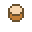 | Player Avatar | This represents the player.
   | Base Node and Path | This is a basic node/path that the player can use to move around in the game.
 | Finish Node | This is the node the player must reach to win the minigame. Can be disabled.
 | Disabled Node | This means the node beneath it is currently disabled, so the player cannot interact with it.
     | Locked Node | This node starts out in the locked state. Once the player completes its puzzle, it will unlocked connected locked paths. Can be disabled.
   | Swap Node | When the player completes its puzzle, it will swap the state of all connected swap paths from revealed to hidden or vice versa. Can be disabled.
     | Checkpoint Node | When the player completes the puzzle of all checkpoint nodes in a group, it will unlock whatever node or checkpoint path they are connected to. Can be disabled.
   | Light Node | When the player completes the puzzle of all light nodes, it will remove fog of war (if turned on) and unlock whatever node or light path they are connected to. Can be disabled.
 | Key Node | When the player interacts with this node, it will reveal part of the puzzle for a connected locked node. Can be disabled.
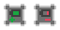  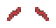 | Charge Node | When the player interacts with this node, it will either transfer a charge to the player if the node is charged and the player isn’t already charged, or take a charge from the player. While the node has a charge, any node connected to it (showing a wire graphic between them) will be enabled. If the node does not have a charge, any node connected to it will be disabled.
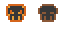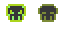 | Antivirus | An enemy. If the player touches one, they will lose a live and the minigame will soft reset. If the player has a charge, that charge will be used up and the antivirus they touch will be destroyed. Different types of antivirus can have different speeds and look different. Antiviruses will start inactive, but will activate once the player moves into their line of sight. An active antivirus will chase the player as long as there is an open path to move towards them.
Hacking Minigame Editor
The hacking minigame editor can only be run in Debug mode. In the editor, you can play games you’ve already made or imported, create/edit games, or import/export games.
Play Game
Playing a game in the editor allows you to test out your games you’re creating, as well as make them available for using your main game by winning the minigame. If you’ve won your minigame since the last time you’ve saved it, it will appear with a [★] next to it, meaning it can be played by the player.
Game Editor
In the Game Editor, you can create a new game from scratch, edit an existing game, or delete a game.
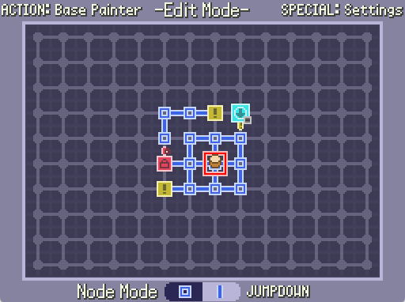
While in the Game Editor, you can use JUMPUP and JUMPDOWN to toggle between Node Mode and Path Mode. As the names suggest, each of these modes allow you to add nodes or paths, respectfully, using the USE key. The ACTION key toggles the Base Painter, which will add Base Nodes or Base Paths wherever your cursor goes. This makes it easy to setup a basic layout.
In Node Mode, you can place a new node at an empty spot, or replace a Basic Node with a different node. On Basic Nodes only, you can add an Antivirus or set the starting position for the player.
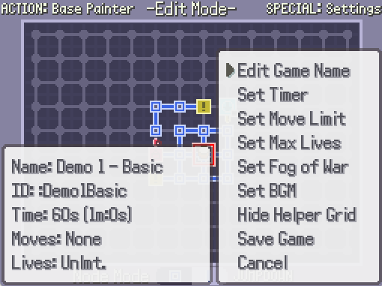
In Path Mode, you can add a path between two nodes. Position your cursor on an existing node that has surrounding nodes, then use the USE key. After that, use the direction keys to add a path in that direction. For example, if you want to add a path between the current node and the node to the left, use the Left direction key. If a path already exists in that position, you will be asked to delete the path, instead. Use the BACK key to be able to move your cursor again.
The SPECIAL key will open the Settings menu, which displays various traits of the game, allows you to change different aspects of the game, and allows you to save your game.

Import Game & Export Game
You can import games created by other developers or export games you’ve created.
To import a game, you must have .hxgm files (which are the file type exported from the editor) saved in the folder set in GAME_FILEPATH in 000_Settings. By default, this is Plugins/Hacking Minigame/Games
The plugin comes with 5 demo games you can import to get started.

